**Angular Advance 2**

External API calls GET/POST/PUSH /DELETE

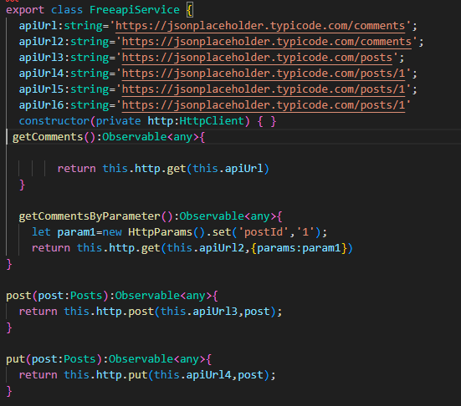

**Routing**

